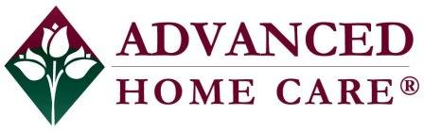

580 Kirts Blvd., Suite 309, Troy, MI 48084
Advanced Home Care Private Duty, Inc.
Now Hiring!!

Home Health Aides, CNA’s, LPN’s, & RN’s
• Full-Time • Part-Time
Night and Day Shift openings
Hartland and Howell

Must have at least 1 year of health care experience, proof of auto insurance and valid Driver’s License.
Offers of employment will be conditional upon successfully passing a pre-employment written test, drug test and criminal background check.

Competitive Benefit and Compensation Package!

Online: http://www.indeed.com/cmp/Advanced-Home-Care-2
Email resume: careers@advancedhomecare.net

